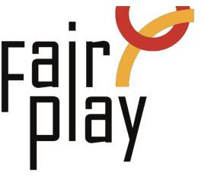

SUBMISSION OF CANDIDACY QUESTIONNAIRE FOR C.I.F.P. AWARDS
NOMINATIONS FOR THE YEAR 2025

Pierre de Coubertin World Fair Play Trophy - 2025
Pierre de Coubertin World Fair Play Trophy to an athlete, or a team, for an ACT of Fair Play that cost, or could have cost his/her victory, or could have downgraded his sport performance.

1. Details of the person or organization proposed for the nomination:
Ms./Mr./organization *
Ms.
Mr.
Organization

Name: *
Country: *
E-mail: *
Profession or current occupation: *

Date of the act: *

Place of the act (city, country): *

Name of the competition: *

2. Description of the act (max.100 words): *

3. Source (preferably in English): *

4. Connection with aspects of fair play: *

6. Details of the person or organization submitting this nomination:
Name: *
E-mail: *

Please attach all available supporting evidence (photos, press clippings, reports etc.) justifying this nomination as well as a PHOTO

